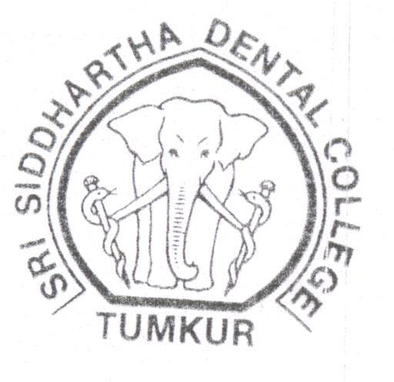

Space for

Photo

Application

Number

________________

Admission

Number

________________

Roll Number

Phone: 0816-2278867

0816-2275536

**Sri Siddhartha Dental College**

**Agalakote, Tumkur Dist**., Karnataka (India)

**(Affiliated to Sri Siddhartha University. SSAHE)**

**Deemed to be University under UGC Act 1956.**

**Application for Admission to the 1st Year B.D.S. Course-**

|  |  |
| --- | --- |
| 1. Name of the Candidate   (Block letters) --- | Mr./Miss. |
| 1. Father’s Name ---   a) Qualification ---  b) Occupation ---  c) Present Address --- |  |
| 1. Name of the guardian and relationship   If the father is not alive  a) Qualification ---  b) Occupation ---  c) Present Address --- |  |
| 1. Permanent address of the candidate   (Block letters) ---  Phone No. / E-mail ID |  |
| 1. i) Permanent address of the father or   guardian  (Block letters) ---  Phone No. |  |
| ii) Local Address  (Block letters) ---  Phone No. |  |
| 1. Telegraphic address of Candidate and father/guardian as well as telephone number, if any --- |  |

(P.T.O)

2

|  |  |  |  |  |  |
| --- | --- | --- | --- | --- | --- |
| 1. a) Nationally ---   b) Religion ---  c) Caste ---  d) Sub-Caste ---  Passport No. --- | | |  | | |
| 1. Annual Income of father / guardian ---- | | |  | | |
| 1. i) Date of birth (in Christian era) ---   ii) Place of birth (Here enter place,  Taluk and District) ---  iii) State of domicile ---  iv) Mother tongue ---  v) Languages which you can read,  write and speak --- | | |  | | |
| 1. a) Name and address of two responsible   persons who can vouch for the  candidates Character ---  b) Name and address of the principal  of the Institution where he/she  studied last --- | | |  | | |
| 1. Name of near relative, if any who   Have been Doctors --- | | |  | | |
| 1. Educational Qualification:   (PUC or 10+2 or Equivalent)   1. Name of the qualifying Examination   Passed ---   1. Reg. No. month and year of   Passing ---   1. Name of University/Board --- 2. State --- | | |  | | |
| Subject | Maximum Marks | Min. Marks | | Marks Obtained | Percentage | |
| 1. English |  |  | |  |  | |
| 1. Regional / Second Language |  |  | |  |  | |
| 1. Total |  |  | |  |  | |

3

|  |  |  |  |  |
| --- | --- | --- | --- | --- |
| Subject | Maximum Marks | Min. Marks | Marks Obtained | Percentage |
| 1. Physics |  |  |  |  |
| 1. Chemistry |  |  |  |  |
| 1. Biology |  |  |  |  |
| 1. Botony |  |  |  |  |
| 1. Zoology |  |  |  |  |
| Total of Science Subject |  |  |  |  |

B.Sc, Degree Examination:

College :

University :

State :

Year of Passing :

|  |  |  |  |  |
| --- | --- | --- | --- | --- |
| Subject | Maximum Marks | Min. Marks | Marks Obtained | Percentage |
| 1. |  |  |  |  |
| 2. |  |  |  |  |
| 3. |  |  |  |  |
| 4. |  |  |  |  |
| 5. |  |  |  |  |
| 6. |  |  |  |  |
| 7. |  |  |  |  |
| TOTAL |  |  |  |  |

(P.T.O)

4

**DECLARATION BY THE CANDIDATE**

I wish to apply for admission to Sri Siddhartha Dental College and declare that I have filled this form myself and to the best of my knowledge and belief, the above particulars are true.

I have gone through the instructions for reservation and admission carefully and undertake to abide by all conditions. I further agree, if admitted, to conform to the rules and regulations at present in force or that may hereafter be made for the administration of the College and Hostel.

**RULES TO BE STRICTLY FOLLOWED BY THE CANDIDATES SEEKING ADMISSIONS**

1. **HOSTELIERS:** if he or she misbehaves with the Management becomes a defaulter for more than a month, refuses to follow the rules imposed by the Management from time to time shall be dismissed from the Hostel unconditionally. He/She shall take prior permission from Authority (Warden/Management) while going out of Hostel other than class hours. While going out of Hostel other than class hours, the Movement Register shall be signed by the Candidate. They are not allowed to keep themselves away from the Hostel for more than 8 (eight) hours continuously without prior permission from the Authority. I am not going to provide any two wheeler or four wheeler Motor Car to my ward until he completes his Degree Course in the College.

**Note:** Visitors of any kind to the Hostel shall take the permission from the Authority visit the Hostels (applicable to both Boys and Girls Hostels.)

1. An Affidavit from the Magistrate shall be obtained and submitted to the Authority.

The student shall execute an affidavit before the Magistrate that He/She shall not participate in any activities against Management either individually or in groups. If such activates are observed, Management is authorised to dismiss the candidate from the college unconditionally without any claim by the Candidate, **I undertake that so long as I am a student of the college, I will do nothing unworthy of a student of the college either inside or outside or anything that will interfere with its orderly working and discipline. I am aware that the Management has the full authority to expel me for disinterest in studies, misbehavior and continuous failure.**

I agree to adhere to the Rules and Regulations, Scheme of study and Examinations of Sri Siddhartha University.

Place:

Date:

Candidate’s Signature

**DECLARATION BY THE PARENT/GUARDIAN**

I hereby declare that I have known the financial obligation and I can afford to pay all the costs and undertake to pay the tuition and other fees payable to the Institution under the rules framed from time to time by the Management of the College.

Place:

Date: Signature of the Parent/Guardian

Are the following attested copies of certificates enclosed Yes/No

1. Marks card of qualifying Examination …………..
2. Transfer Certificate from the Institution last attended …………..
3. Migration Certificate from the Board/University …………..
4. Character / Conduct Certificate from Institution …………..
5. Certificate in proof of Date of Birth …………..
6. Eligibility Certificate from the Sri Siddhartha University …………..
7. Clearance Certificate from New Delhi …………..

(Ministry of Health & Family-Welfare)

1. Student Visa ……………
2. Passport copy ……………
3. Residential Certificate …………..
4. Any Other Certificate …………..

(Item No. 6,7,8,9 & 10 apply to Foreign student only)

**Note:** Originals of the above shall be delivered at the time of admission without which the

Provisional admission is not complete.